Practical 2
Aim: Write a C++ program to implement bubble sort and display the sorted array.
Source-code:
(User-defined Array)
#include<iostream>
using namespace std;
int main()
{
int n,arr[100];
cout<<"Enter no of elements:";
cin>>n;
cout<<"Enter elements:\n";
for(int i=0;i<n;i++){
cin>>arr[i];
}

for(int i=0;i<n-1;i++){
for(int j=0;j<n-i-1;j++){
if(arr[j]>arr[j+1]){
int temp=arr[j];
arr[j]=arr[j+1];
arr[j+1]=temp;
}
}
}
cout<<"Sorted array:";
for(int i=0;i<n;i++){
cout<<arr[i]<<" ";
}
return 0;
}

(Pre-defined Array)
#include<iostream>
using namespace std;
int main()
{
int arr[]={15,16,6,8,5};
int n=5;
for(int i=0;i<n-1;i++){

for(int j=0;j<i-1;j++){

if(arr[j]>arr[j+1]){
int temp=arr[j];
arr[j]=arr[j+1];
arr[j+1]=temp;
}
}
}
cout<<"Sorted array:";
for(int i=0;i<n;i++){
cout<<arr[i]<<" ";
}
return 0;
}

Output:
(For User-defined Array)
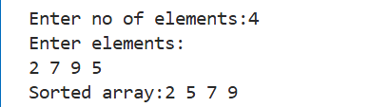

(For Pre-defined Array)
